LAB MST – ADBMS

Name: Manan Verma

UID: 24BAI70008

Section: 24AIT-KRG-1B

Q1: A company stores employees and their departments. Display employees whose salary is greater than the average salary of their own department, but only from departments having at least 3 employees.
Display Department Name, Employee Name, and Salary.

CODE:
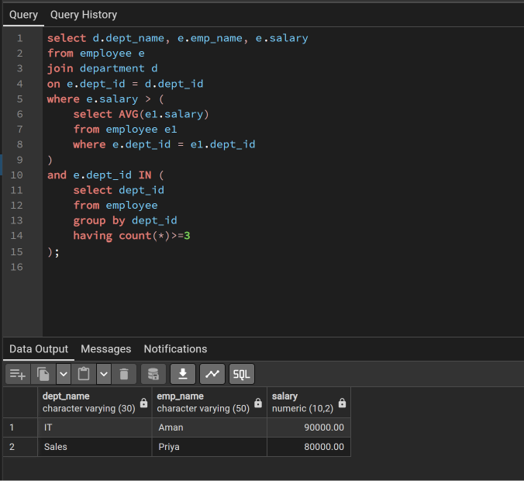
OUTPUT:
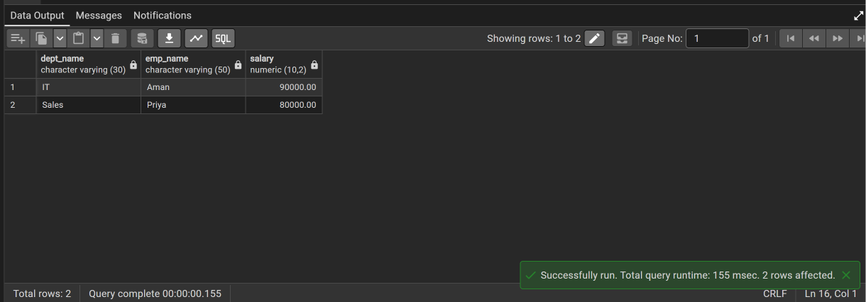

Q2: A bank maintains customer information in bank_customer. Create a PostgreSQL trigger that automatically stores a log in customer_audit whenever a customer is inserted or deleted. Store Customer ID, Customer Name, action (ADDED/REMOVED), and current timestamp.

Code:
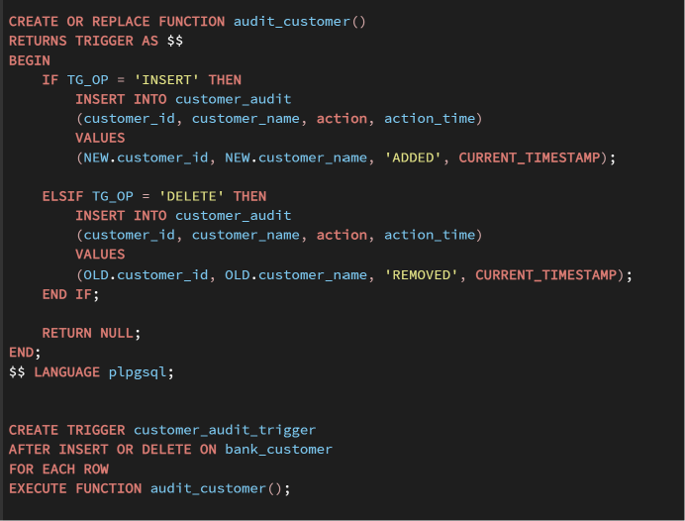
Output:
